Asimov, 100 Great Fantasy Short Short Stories, Doubleday 1984 First Edition, First Print (Gutter code - Z1 January 1984). Fine unclipped dust jacket with price $15.95. As shown in photos there is a half inch hole on bottom of the back and a half inch hole on bottom of spine. As new hardcover quarter bound in black cloth and red board with silver spine lettering, Octavo. All 311 pages tightly bound and no marks of any kind. Jacket art Plus One Studios ISBN 0385181655
“Merely 2,000 words to range over the full scope of the unreasonable, and to pluck from that scope a satisfying tale.” Anthology includes stories by H.P. Lovecraft, Harlan Ellison, Fredric Brown, Barry N. Malzberg, Isaac Asimov, Roger Zelazny, Jane Yolen, Clark Ashton Smith, Avram Davidson, James Sallis, Katherine Maclean, and many others.
ID 000297 Price $33 Box 27
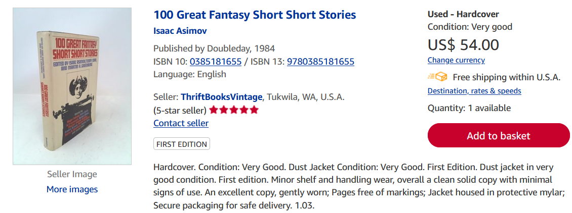
AbeBooks New $47.00 Used $25 to $74

